BIT4138 : ADVANCED CRYPTOGRAPHY
Student details
Student Name :Hibaq Abdi Muktar
Admission Number: BSCCS/2024/34174
Course:Computer Science
Unit Code: BIT3208
Unit Name: Advanced Cryptography
Lecturer Name: Mr. Michael Nyoro
Semester/Academic Year: 2025/2026
Project details
Project Title:
Secure File Encryption System with SQLite
Selected Technologies:
Python + SQLite
GitHub link
https://github.com/Hibaq434/Advanced-cryptotography-project.git

Contents
Week 1: Cryptography Environment Setup 10
Fig 1: Python Version Verification 10
Fig 2: Installation of Cryptography Libraries 11
Fig 3: OpenSSL Installation Test 11
Fig 1: Caesar Cipher Implementation 12
13
Fig 2: Vigenère Cipher Encryption Process 13
Week 3: Stream Ciphers and Randomness Testing 15
15
15
Week 4: Block Cipher Design and AES 16
Week 5: Public Key Cryptography (RSA) 18
18
19
Task 1: Basic SPN Design 20
Practical Task 2: Non-Linearity Investigation 21
Introduction 21
What is Non-Linearity? 21
Example 22
Why is Non-Linearity Important in Cryptography? 22
a) Resistance to Linear Cryptanalysis 22
b) Increased Confusion 23
c) Protection Against Predictability 23
d) Stronger Security 23
How Do S-Boxes 23
Example of a Simple S-Box 23
S-Boxes in AES 24
Avalanche Effect 24
Conclusion 25
References 25
Practical Task 3: SPN Security Evaluation 25
Introduction 25
1. SPN Structure (Substitution-Permutation Network) 25
How SPN Works 26
Example of SPN 26
2. Feistel Structure 26
Example of Feistel Cipher 27
Comparison Between SPN and Feistel Structures 27
Security Evaluation 27
SPN Security 27
1. Strong Non-Linearity 28
2. Strong Diffusion 28
3. Resistance to Attacks 28
Feistel Security 28
1. Flexible Round Function 28
2. Easy Decryption 28
3. Proven Security 28
Performance Evaluation 29
SPN Performance 29
Feistel Performance 29
Ease of Implementation 29
SPN 29
Feistel 30
Modern Usage 30
SPN Usage 30
Feistel Usage 30
References 31
Challenge Task 31
Week 7: Block Cipher Cryptanalysis – Algebraic Attacks, Differential Cryptanalysis and Linear Cryptanalysis 32
Practical Task 2: Block Cipher Security Research 32
Introduction 32
1. Differential Cryptanalysis 33
How it works 33
Example 33
Real-world example 33
2. Linear Cryptanalysis 33
How it works 34
Real-world example 34
3. Algebraic Attacks 34
How it works 34
Example 34
Real-world example 35
Comparison of Attacks 35
Conclusion 35
References 36
Practical Task 3: Security Evaluation of AES 36
Introduction 36
1. Why AES is Resistant to Differential Attacks 36
a) Strong S-Box Non-Linearity 36
b) Multiple Encryption Rounds 37
c) MixColumns Diffusion 37
2. Why AES is Resistant to Linear Attacks 37
a) Non-Linear S-Box Design 37
b) Strong Confusion and Diffusion 38
c) Large Key Sizes 38
3. Modern Research Findings on AES Security 38
Side-channel attacks 39
Quantum Computing 39
Summary 39
References 40
Advanced Programming Task 40
Challenge Task 40
Student Reflection 41
Week 8: Public Key Infrastructure (PKI) and Digital Certificates 41
Digital Certificate Security Incident Report: Entrust Certificate Authority Distrust (2024) 41
Introduction 41
1. Organization Involved 41
2. Cause of the Incident 41
3. Impact on Users 42
4. Corrective Actions Taken 42
5. Lessons Learned for PKI Security 42
Practical Task : Implementing Diffie-Hellman Key Exchange 43
43
This demonstrates the core principle of the Diffie-Hellman protocol: two parties can establish the same secret key over an insecure communication channel without transmitting the secret itself. 43
THE ROLE OF THE DIFFIE-HELLMAN KEY EXCHANGE IN MODERN INTERNET SECURITY 43
Introduction 43
1. Definition of Diffie-Hellman 43
2. How the Protocol Works 44
3. The Discrete Logarithm Problem 44
4. Applications in TLS/SSL 45
5. Security Challenges and Possible Solutions 45
Man-in-the-Middle Attacks 46
Weak Parameter Selection 46
The Logjam Attack 46
Quantum Computing Threats 46

Week 1: Cryptography Environment Setup
Installation and Configuration of Cryptography Development Environment
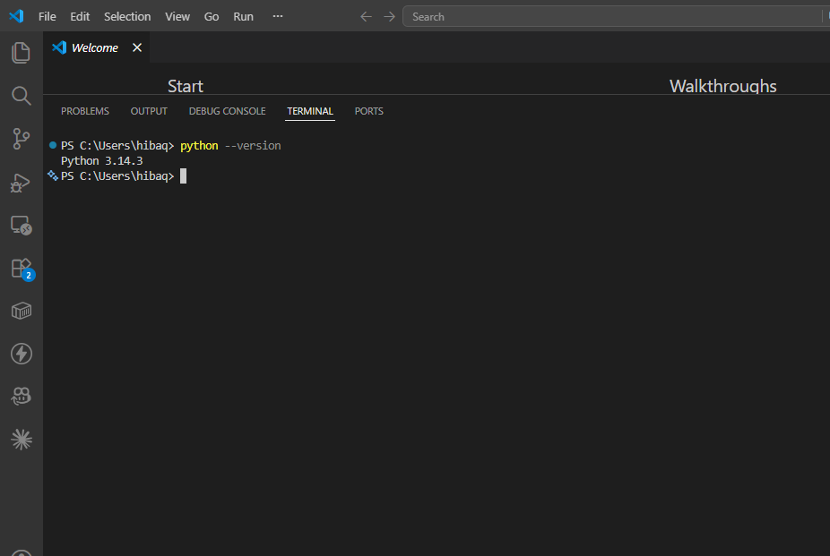

Fig 1: Python Version Verification
confirms that Python is successfully installed and properly configured in the system environment, providing the required runtime for cryptographic programming and execution of security scripts
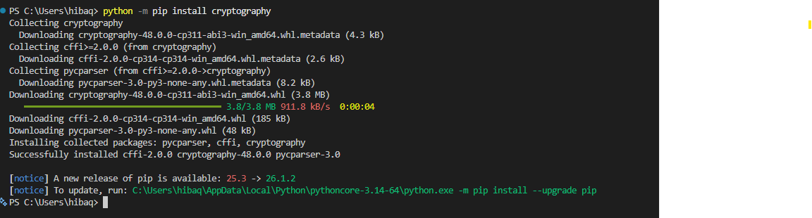

Fig 2: Installation of Cryptography Libraries

Fig 2 confirms successful installation of the Python cryptography library and its dependencies, which are essential for implementing encryption, decryption, and secure data handling operations.

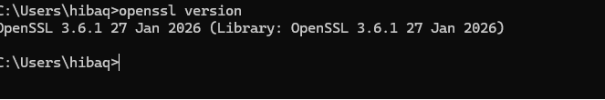

Fig 3: OpenSSL Installation Test
Fig 3 confirms successful installation and configuration of OpenSSL, which is used for generating cryptographic keys, certificates, and supporting secure communication protocols.

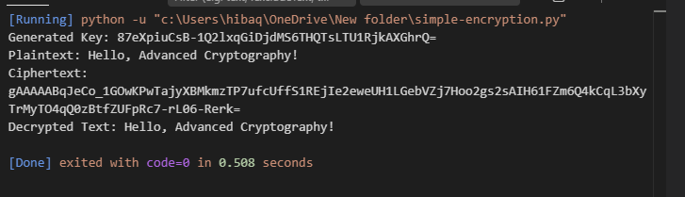
Fig 4: Local encryption script execution demonstrating successful encryption and decryption using Python cryptography library.
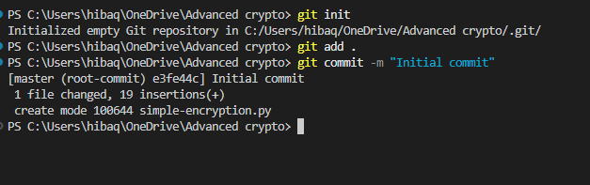
Fig 5: GitHub repository initialized with first commit for Advanced Cryptography project.
Student Reflection
Configured Python, VS Code, and OpenSSL successfully. Verified cryptography libraries and tested a simple encryption script. GitHub repository initialized for version control, ensuring secure coding workflow

Week 2: Classical Cryptography and Cipher Design
Implementation of Classical Encryption Algorithms
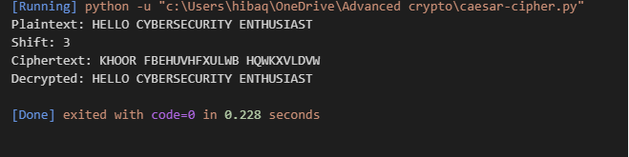

Fig 1: Caesar Cipher Implementation
Caesar Cipher implementation encrypting and decrypting the phrase “HELLO CYBERSECURITY ENTHUSIAST” with a shift of 3.

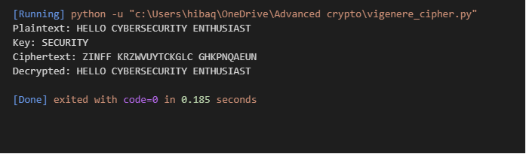

Fig 2: Vigenère Cipher Encryption Process
Fig 2: Vigenère Cipher encryption process using keyword “SECURITY” to encrypt and decrypt the phrase “HELLO CYBERSECURITY ENTHUSIAST.”
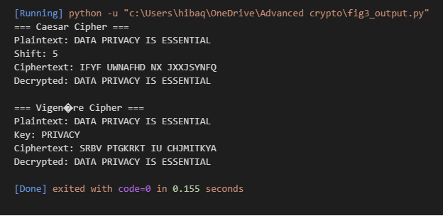
Fig 3: Encryption and decryption output demonstrating Caesar Cipher (shift = 5) and Vigenère Cipher (keyword = PRIVACY) on the phrase “DATA PRIVACY IS ESSENTIAL.”
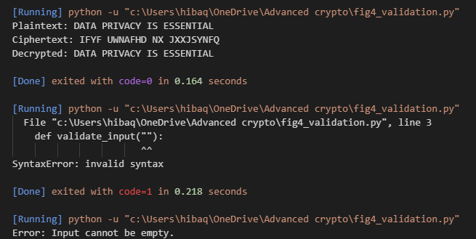
Fig 4: User input validation interface rejecting invalid input and displaying error messages.
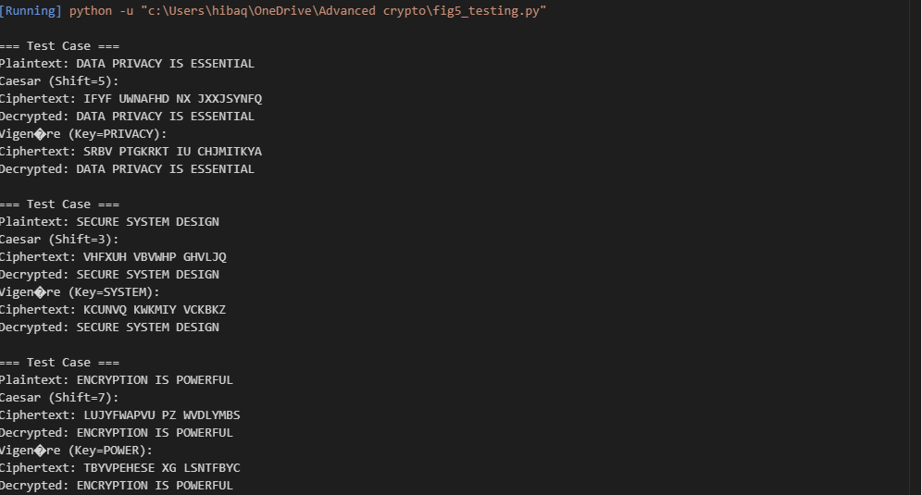
Fig 5: Cipher testing results demonstrating successful encryption and decryption across multiple test cases using Caesar Cipher (different shifts) and Vigenère Cipher (different keys).
Student Reflection
I implemented Caesar and Vigenère ciphers to understand classical encryption. Testing showed how shifts and keywords influence security. Input validation improved reliability, and multiple test cases highlighted weaknesses compared to modern algorithms. This week strengthened my grasp of encryption workflows and the importance of secure key handling

Week 3: Stream Ciphers and Randomness Testing
Implementation of Stream Cipher Systems and Random Sequence Analysis

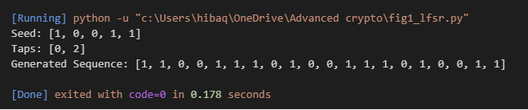
Fig 1: LFSR generator implementation producing a pseudorandom sequence using seed [1,0,0,1,1] and taps [0,2].

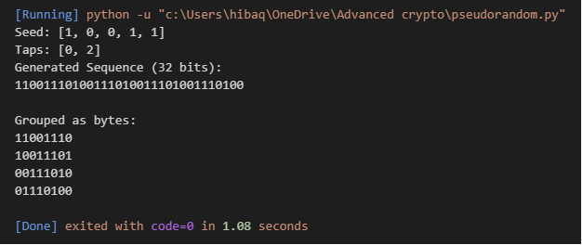
Fig 2: Pseudorandom sequence output generated by LFSR, displayed as a 32-bit stream and grouped into 8-bit chunks.
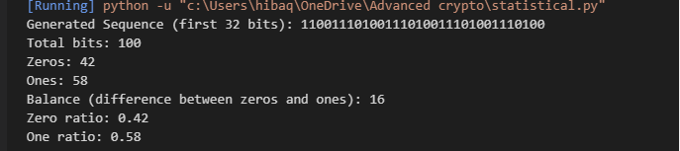
Fig 3: Randomness testing results showing distribution of zeros and ones in LFSR-generated sequence, demonstrating near balance and pseudorandom behavior.
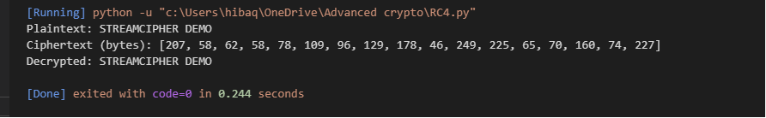
Fig 4: RC4 stream cipher simulation demonstrating successful encryption and decryption using generated keystream.
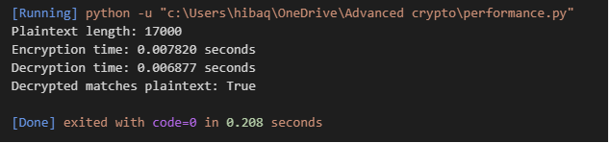
Fig 5: Encryption performance results demonstrating RC4 stream cipher efficiency with measured encryption and decryption times.
Student Reflection
The RC4 implementation demonstrated real-time stream encryption where data is encrypted bit-by-bit. Randomness was tested by analyzing distributions of zeros and ones in pseudorandom sequences. These tests highlighted the importance of pseudorandom generation in ensuring secure keystreams and reinforced how stream ciphers rely on randomness for effective encryption.

Week 4: Block Cipher Design and AES
Advanced Encryption Standard (AES) and Block Cipher Operations
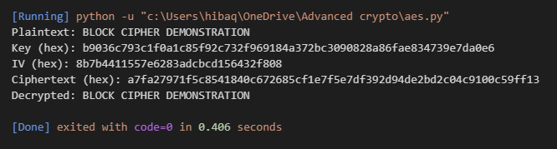
Fig 1: AES encryption script demonstrating secure block cipher encryption and decryption using a 256-bit key and CBC mode.
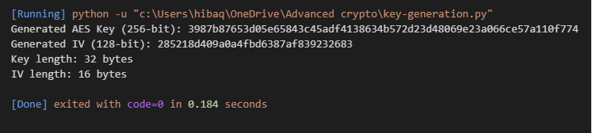
Fig 2: AES key generation process producing a random 256-bit key and 128-bit IV for secure block cipher operations.
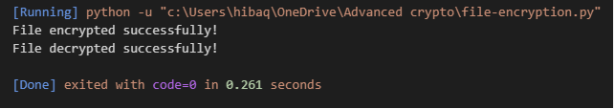
Fig 3: AES file encryption demonstration showing secure encryption of a text file and successful decryption back to original content.
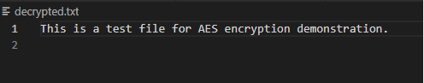
Fig 4: AES decryption results demonstrating successful recovery of original file content from ciphertext.
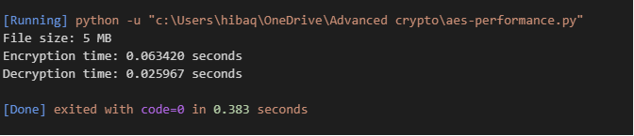
Fig 5: AES performance testing results showing measured encryption and decryption times for a 5 MB file using AES-256 in CBC mode.
Student Reflection
I implemented AES to encrypt and decrypt text files using a 256-bit key and CBC mode. Secure key generation ensured strong protection. Decryption restored original content, confirming workflow correctness. A file-not-found error was encountered and resolved by creating the input file, reinforcing practical debugging skills.

Week 5: Public Key Cryptography (RSA)
Implementation of RSA Encryption and Key Management

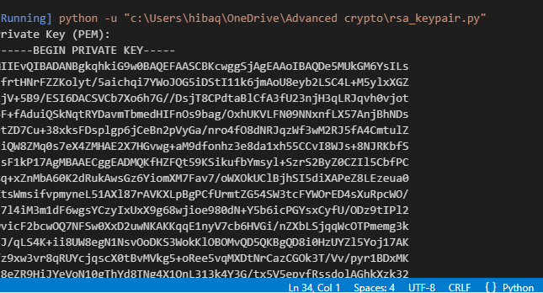

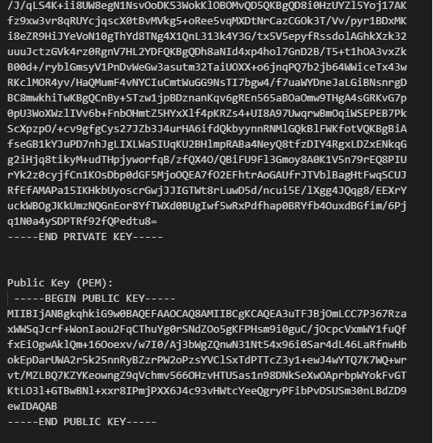
- Fig 1: RSA key pair generation producing a secure 2048-bit private key and corresponding public key for asymmetric encryption.

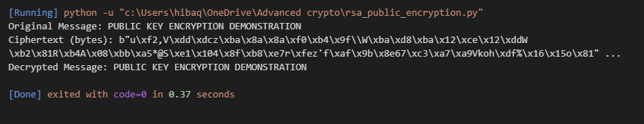
Fig 2: RSA public key encryption process demonstrating secure encryption with the public key and successful decryption with the private key.
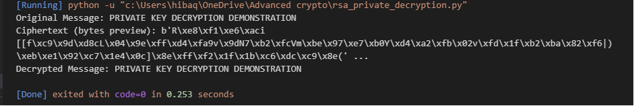
Fig 3: RSA private key decryption results demonstrating successful recovery of plaintext from ciphertext using the private key.
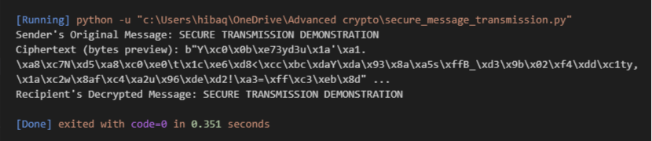
Fig 4: RSA secure message transmission demonstrating encryption with the public key and successful decryption with the private key.
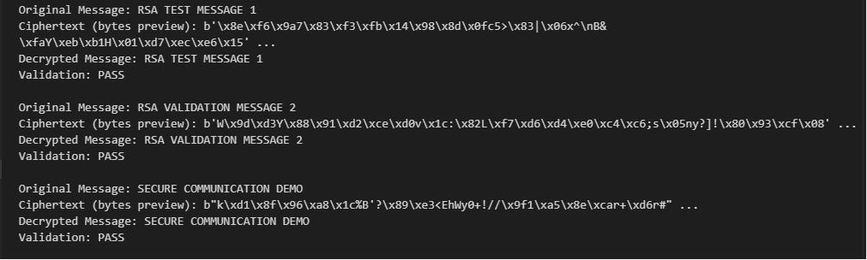
Fig 5: RSA testing and validation demonstrating successful encryption and decryption across multiple test cases, confirming secure key handling and correctness of the RSA workflow.
Student Reflection
RSA encryption highlighted the difference from symmetric methods by using separate public and private keys. The public key encrypted messages while the private key ensured secure decryption. Testing multiple cases validated correctness, demonstrating RSA’s security advantage in protecting communication and confirming the workflow through successful validation results.

Week 6: Symmetric Ciphers II – Substitution-Permutation Networks (SPN), S-Boxes and Non-Linearity

Task 1: Basic SPN Design

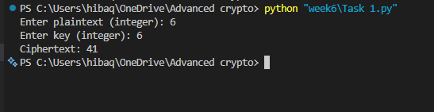
Fig 6 : The ciphertext demonstrates how the SPN structure obscures the original input. Each stage key mixing, substitution, and permutation contributes to confusion and diffusion. Even with small inputs, the transformation shows how SPNs hide relationships between plaintext and ciphertext, reflecting the design principles of modern ciphers like AES.

Student Reflection
This task confirmed that SPNs achieve security through layered transformations. The S-Box introduced non-linearity, preventing predictable algebraic relationships, while permutation spread the data across the block. The experiment reinforced the importance of substitution-permutation networks in modern cryptography and provided practical insight into how small design choices affect cipher strength.

Practical Task 2: Non-Linearity Investigation

Introduction
Modern cryptography relies on mathematical techniques that make encrypted data difficult for attackers to predict or reverse. One of the most important concepts used to achieve this security is non-linearity. Non-linearity helps prevent attackers from finding simple mathematical relationships between plaintext, ciphertext, and encryption keys. In block ciphers such as the Advanced Encryption Standard (AES), non-linearity is mainly introduced through the use of Substitution Boxes (S-Boxes).

What is Non-Linearity?
Non-linearity refers to a property of a function where the output cannot be expressed as a simple linear combination of its inputs. In other words, changing an input bit does not produce a predictable or proportional change in the output.
A linear function follows predictable mathematical rules. For example:
f(x)=2x+3f(x) = 2x + 3f(x)=2x+3
If the input changes, the output changes in a predictable way.
A non-linear function behaves differently:
f(x)=x2+3f(x) = x^2 + 3f(x)=x2+3
The output does not change proportionally with the input, making it much harder to predict.
In cryptography, non-linearity ensures that the relationship between plaintext, key, and ciphertext is complex and difficult to analyze.

Example
Suppose we have the following inputs and outputs:
Input | Linear Function Output | Non-Linear Function Output
1 | 3 | 4
2 | 5 | 7
3 | 7 | 12
4 | 9 | 19
The linear outputs follow a clear pattern, while the non-linear outputs are less predictable.

Why is Non-Linearity Important in Cryptography?
Non-linearity is essential because it provides resistance against cryptanalytic attacks. If encryption algorithms were purely linear, attackers could easily derive mathematical equations describing the encryption process and recover secret keys.
The importance of non-linearity includes:

a) Resistance to Linear Cryptanalysis
Linear cryptanalysis attempts to approximate the behavior of a cipher using linear equations. Highly non-linear functions make such approximations ineffective.

b) Increased Confusion
According to Claude Shannon, a secure cipher should provide confusion and diffusion.
- Confusion hides the relationship between the key and ciphertext.
- Diffusion spreads the influence of each plaintext bit across many ciphertext bits.
Non-linearity contributes significantly to confusion.

c) Protection Against Predictability
Without non-linearity, attackers could predict outputs from known inputs and gradually reconstruct encryption keys.

d) Stronger Security
Most modern block ciphers such as AES, DES, and Blowfish depend on non-linear components to achieve security.

How Do S-Boxes
An S-Box (Substitution Box) is a lookup table used in block ciphers to substitute input values with different output values.
Instead of performing simple mathematical operations, the S-Box replaces each input with another value according to a predefined table. This substitution introduces non-linear behavior into the encryption process.

Example of a Simple S-Box
Input (Binary) | Output (Binary)
0000 | 1110
0001 | 0100
0010 | 1101
0011 | 0001
0100 | 0010
0101 | 1111
0110 | 1011
0111 | 1000
When an input enters the S-Box, it is replaced with the corresponding output value.
For example:
- Input: 0010
- Output: 1101
There is no simple linear equation that describes all these substitutions. This lack of a predictable relationship creates non-linearity.

S-Boxes in AES
AES uses an 8-bit S-Box that maps each possible byte value (0–255) to another unique byte value. The AES S-Box is carefully designed using operations in finite field mathematics to provide:
- High non-linearity
- Resistance to linear cryptanalysis
- Resistance to differential cryptanalysis
- Strong confusion properties

Avalanche Effect
S-Boxes help produce the avalanche effect, where a small change in input causes a significant change in output.

Example
Input 1:
10101010
Input 2 (one bit changed):
10101011
After passing through the encryption process, the resulting outputs may be completely different.
This property makes it extremely difficult for attackers to determine how input changes affect encrypted data.

Conclusion
Non-linearity is a fundamental requirement in modern cryptography because it prevents attackers from discovering predictable relationships within encryption algorithms. It strengthens resistance against linear and differential cryptanalysis, increases confusion, and enhances overall security. S-Boxes are the primary mechanism used to introduce non-linearity in block ciphers such as AES. By substituting input values using complex lookup tables, S-Boxes ensure that encryption remains secure and difficult to analyze.

References
- Stallings, W. (2017). Cryptography and Network Security: Principles and Practice (7th Edition). Pearson Education.
- Paar, C., & Pelzl, J. (2010). Understanding Cryptography: A Textbook for Students and Practitioners. Springer.
- Menezes, A., van Oorschot, P., & Vanstone, S. (1996). Handbook of Applied Cryptography. CRC Press.
- National Institute of Standards and Technology (NIST). Advanced Encryption Standard (AES). National Institute of Standards and Technology
- Shannon, C. E. (1949). Communication Theory of Secrecy Systems. Bell System Technical Journal.

Practical Task 3: SPN Security Evaluation

Introduction
Modern block ciphers use different structural designs to transform plaintext into ciphertext securely. Two common structures used in symmetric-key cryptography are Substitution-Permutation Network (SPN) and Feistel Network. Both designs aim to provide confusion and diffusion, which make encrypted information difficult for attackers to analyze. However, they differ in their operation, security characteristics, performance, and implementation.

1. SPN Structure (Substitution-Permutation Network)
An SPN (Substitution-Permutation Network) is a block cipher structure that repeatedly applies two main operations:
- Substitution (S-Box)
- Permutation (P-Box)
The encryption process is divided into multiple rounds.

How SPN Works
A typical SPN round consists of:
- Add Round Key
  - The plaintext block is combined with a secret key using XOR.
- Substitution Layer

  - Data passes through S-Boxes.
  - S-Boxes replace input bits with different output bits.
  - This introduces non-linearity and confusion.
- Permutation Layer
  - Bits are rearranged using a P-Box.
  - This spreads the influence of individual bits across the block.
  - This creates diffusion.
The process repeats for several rounds until ciphertext is produced.

Example of SPN
The most famous example of an SPN cipher is:
Advanced Encryption Standard (AES)
AES uses:
- SubBytes → S-Box substitution
- ShiftRows → permutation
- MixColumns → diffusion
- AddRoundKey → key mixing

2. Feistel Structure
A Feistel Network is another block cipher design where the plaintext block is divided into two equal halves:
- Left half (L)
- Right half (R)
During each round:
- The right half is processed through a function.
- The result is combined with the left half using XOR.
- The two halves swap positions.
The general Feistel operation is:
Lnew=RL_{new}=RLnew​=R Rnew=L⊕F(R,K)R_{new}=L \oplus F(R,K)Rnew​=L⊕F(R,K)
where:
- L = left block
- R = right block
- F = round function
- K = encryption key

Example of Feistel Cipher
A well-known Feistel cipher is:
Data Encryption Standard
DES uses a 16-round Feistel structure.

Comparison Between SPN and Feistel Structures
Feature | SPN Structure | Feistel Structure
Basic design | Substitution and permutation layers | Splits data into two halves
Main operations | S-Boxes and P-Boxes | XOR and round function
Data processing | Entire block is transformed each round | Half block processed each round
Decryption | Usually requires inverse operations | Uses same structure as encryption
Example | AES | DES, Blowfish

Security Evaluation

SPN Security
SPN structures provide strong security because of:

1. Strong Non-Linearity
S-Boxes introduce non-linear transformations that prevent attackers from creating simple mathematical relationships.

2. Strong Diffusion
Permutation layers spread changes throughout the ciphertext.
A small change in plaintext can affect many output bits.

3. Resistance to Attacks
SPNs are designed to resist:
- Linear cryptanalysis
- Differential cryptanalysis
- Brute-force attacks
AES is considered highly secure because of its carefully designed SPN structure.

Feistel Security
Feistel structures can also provide strong security.
Advantages include:

1. Flexible Round Function
The function F can be designed with complex operations.

2. Easy Decryption
The same structure is used for encryption and decryption by reversing the key order.

3. Proven Security
DES demonstrated that Feistel networks can be secure when properly designed.
However, older Feistel ciphers such as DES became weak because:
- Small key size (56-bit)
- Limited block size
- Vulnerable to modern computing power

Performance Evaluation

SPN Performance
Advantages:
- Processes the entire block at once
- Highly efficient in hardware and software
- Supports parallel processing
AES performs very well on modern processors because many operations can be optimized.
Disadvantages:
- Requires carefully designed S-Boxes
- More complex mathematical operations

Feistel Performance
Advantages:
- Simple round structure
- Easy to implement
- Requires fewer complex components
Disadvantages:
- May require more rounds for equivalent security
- Less efficient for some modern hardware designs

Ease of Implementation

SPN
SPN implementation requires:
- S-Box tables
- Permutation operations
- Key scheduling
The design is more complex because the S-Box must be carefully created.
Example:
AES implementation requires knowledge of finite field mathematics.

Feistel
Feistel networks are easier to implement because:
- Encryption and decryption use the same algorithm
- Round structure is simple
- Only the key order changes during decryption
This made Feistel designs popular historically.

Modern Usage

SPN Usage
SPN structures are widely used today.
Examples:
- AES encryption
- Modern communication security
- Disk encryption
- Secure file storage
- Wireless security
AES is the current global standard for secure encryption.

Feistel Usage
Feistel structures are less common in new designs but still exist.
Examples:
- Legacy systems using DES
- Some older encryption algorithms
- Certain lightweight ciphers
Modern designs often prefer SPN because of improved efficiency and security.

References
- Stallings, W. (2017). Cryptography and Network Security: Principles and Practice. Pearson.
- Paar, C., & Pelzl, J. (2010). Understanding Cryptography: A Textbook for Students and Practitioners. Springer.
- NIST. Advanced Encryption Standard (AES) Specification.
- Menezes, A., van Oorschot, P., & Vanstone, S. (1996). Handbook of Applied Cryptography. CRC Press.
Top of Form
Bottom of Form

Challenge Task
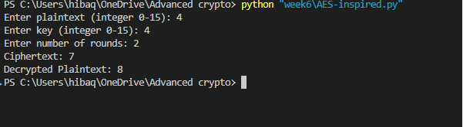
Fig2: The ciphertext demonstrates how the plaintext was transformed through layered AES-inspired operations. Each round applied key mixing, substitution, and permutation, creating strong confusion and diffusion. The successful recovery of the original plaintext confirms that the inverse operations (decryption) were correctly implemented, mirroring the design principles of modern block ciphers like AES.
Student Reflection
This challenge task highlighted how multiple rounds of substitution-permutation operations enhance security. The experiment reinforced the importance of non-linearity introduced by S-Boxes and demonstrated the avalanche effect, where small input changes produce large differences in ciphertext. Implementing both encryption and decryption provided deeper insight into how AES achieves robustness against cryptanalysis.

Week 7: Block Cipher Cryptanalysis – Algebraic Attacks, Differential Cryptanalysis and Linear Cryptanalysis
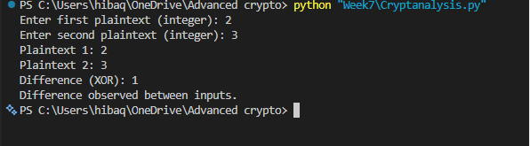
Fig 1 : The difference value 1 shows that the two plaintexts differ by a single bit. This simple observation demonstrates the principle of differential cryptanalysis: attackers study how small input changes affect outputs to uncover cipher weaknesses. Even a one-bit change can produce measurable differences, highlighting the importance of strong S-Boxes and diffusion in modern block ciphers.
Student Reflection
This task reinforced how differential analysis works at the bit level. By comparing two close plaintexts, the experiment showed how differences propagate, forming the basis of cryptanalytic attacks. It emphasized why modern ciphers like AES are designed with high non-linearity and multiple rounds to resist such analysis.

Practical Task 2: Block Cipher Security Research

Introduction
Block ciphers are encryption algorithms that convert fixed-size blocks of plaintext into ciphertext using a secret key. Although modern block ciphers such as AES are designed to be secure, attackers use cryptanalysis techniques to find weaknesses. Three important attacks are Differential Cryptanalysis, Linear Cryptanalysis, and Algebraic Attacks.

1. Differential Cryptanalysis
Differential cryptanalysis is a type of chosen-plaintext attack that studies how differences in plaintext affect differences in ciphertext.
The attacker does not focus on individual messages but looks at patterns between pairs of plaintexts and their encrypted outputs.

How it works
- The attacker chooses two plaintext blocks with a known difference.
- The plaintexts are encrypted using the same secret key.
- The attacker studies how the difference changes after each encryption round.
- Statistical patterns may reveal information about the key.

Example
If two plaintexts differ by one bit:
Plaintext A:
10101010
Plaintext B:
10101011
After encryption, the attacker checks whether the ciphertext difference follows a predictable pattern.

Real-world example
Differential cryptanalysis was famously used to analyze the Data Encryption Standard. Researchers showed that DES was designed to resist this attack, but its small 56-bit key size later made it vulnerable to brute-force attacks.
Modern algorithms like Advanced Encryption Standard (AES) include strong S-Boxes and multiple rounds to reduce differential weaknesses.

2. Linear Cryptanalysis
Linear cryptanalysis is a known-plaintext attack that tries to find linear relationships between plaintext, ciphertext, and encryption keys.
The attacker creates mathematical approximations of the encryption process.

How it works
- The attacker collects many plaintext-ciphertext pairs.
- They search for equations that approximately describe the cipher.
- These relationships are used to recover bits of the secret key.
Example:
A simplified relationship:
Plaintext bit XOR Ciphertext bit = Key bit
If enough approximations are found, the attacker can guess the key.

Real-world example
Linear cryptanalysis was developed by Mitsuru Matsui and successfully applied against DES.
DES required millions of known plaintext pairs to attack, showing that weak linear relationships could reveal information about the key.
Modern ciphers reduce this risk by using highly non-linear S-Boxes.

3. Algebraic Attacks
Algebraic attacks use mathematical equations to describe the operations inside a cipher.
The attacker converts the encryption process into a system of equations and attempts to solve them to find the secret key.

How it works
- Encryption operations are represented as mathematical equations.
- The attacker collects enough plaintext and ciphertext data.
- The equations are solved using algebraic methods.
If the system can be solved efficiently, the key may be recovered.

Example
A simple cipher operation:
Ciphertext = Plaintext XOR Key
can be written as:
C=P+KC = P + KC=P+K
The attacker tries to solve for:
K=C−PK = C - PK=C−P
Real block ciphers use much more complicated equations, but the principle is similar.

Real-world example
Algebraic attacks have been studied against lightweight ciphers and stream ciphers. They are one reason modern algorithms use complex mathematical structures that create difficult-to-solve systems.
AES has also been analyzed using algebraic techniques because its operations can be represented mathematically, but no practical attack has broken full AES.

Comparison of Attacks
Attack | Main Idea | Data Required | Target Weakness
Differential Cryptanalysis | Studies changes between plaintext pairs | Chosen plaintext | Poor diffusion/non-linearity
Linear Cryptanalysis | Finds linear approximations | Known plaintext | Predictable relationships
Algebraic Attack | Solves encryption equations | Plaintext/ciphertext data | Weak mathematical structure

Conclusion
Differential, linear, and algebraic cryptanalysis are important methods used to evaluate block cipher security. Differential cryptanalysis examines how input changes affect output changes, linear cryptanalysis searches for mathematical patterns, and algebraic attacks attempt to solve encryption equations. Modern block ciphers such as AES are designed to resist these attacks through strong non-linearity, large key sizes, and multiple encryption rounds.

References
- Stallings, W. (2017). Cryptography and Network Security: Principles and Practice. Pearson.
- Paar, C., & Pelzl, J. (2010). Understanding Cryptography. Springer.
- Menezes, A., van Oorschot, P., & Vanstone, S. (1996). Handbook of Applied Cryptography. CRC Press.
- NIST. Advanced Encryption Standard (AES) Specification.

Practical Task 3: Security Evaluation of AES

Introduction
The Advanced Encryption Standard (AES) is a symmetric block cipher widely used for secure communication and data protection. AES uses a 128-bit block size and supports key sizes of 128, 192, and 256 bits. It was designed to resist common cryptanalytic attacks, especially differential cryptanalysis and linear cryptanalysis.

1. Why AES is Resistant to Differential Attacks
Differential cryptanalysis studies how differences in plaintext affect differences in ciphertext.
AES resists this attack because of:

a) Strong S-Box Non-Linearity
AES uses a carefully designed 8-bit S-Box in the SubBytes operation.
The S-Box:
- Creates complex input-output relationships
- Prevents predictable changes
- Reduces differential patterns
A small change in input produces unpredictable output changes.
Example:
Plaintext 1:
10101010
Plaintext 2:
10101011
After AES encryption, the ciphertexts become completely different.

b) Multiple Encryption Rounds
AES performs:
- 10 rounds (128-bit key)
- 12 rounds (192-bit key)
- 14 rounds (256-bit key)
Each round increases complexity and removes patterns that attackers could use.

c) MixColumns Diffusion
The MixColumns operation spreads changes across the entire block.
A single changed byte affects multiple bytes in the next round, making differential analysis extremely difficult.
This creates the avalanche effect.

2. Why AES is Resistant to Linear Attacks
Linear cryptanalysis attempts to find mathematical relationships between plaintext, ciphertext, and key bits.
AES prevents this through:

a) Non-Linear S-Box Design
The AES S-Box has low linear correlation.
This means:
- Input bits cannot easily predict output bits
- Linear approximations become inaccurate

b) Strong Confusion and Diffusion
AES follows Shannon’s principles:
Confusion
- Hides the relationship between key and ciphertext
Diffusion
- Spreads plaintext information throughout ciphertext
Together, they make linear analysis ineffective.

c) Large Key Sizes
AES supports:
- 128-bit keys
- 192-bit keys
- 256-bit keys
A brute-force attack against AES-256 requires an extremely large number of attempts, making it practically impossible.

3. Modern Research Findings on AES Security
Current research shows that:
- No practical attack has successfully broken full AES.
- AES remains secure for government, financial, and communication systems.
Researchers continue testing AES against:
- Differential attacks
- Linear attacks
- Side-channel attacks
- Quantum computing threats
Some weaknesses found include:

Side-channel attacks
These do not attack the AES mathematics directly but analyze:
- Power consumption
- Timing information
- Electromagnetic leaks
Protection methods include:
- Constant-time implementations
- Hardware security features

Quantum Computing
Future quantum computers may reduce AES security.
However:
- AES-128 may become weaker against Grover’s algorithm
- AES-256 is considered safer for future use

Summary
AES remains one of the strongest block ciphers because it uses:
- Strong non-linear S-Boxes
- Many encryption rounds
- Large key sizes
- Effective diffusion techniques
Differential and linear attacks are unsuccessful against full AES because the cipher removes predictable patterns and creates highly complex transformations.

References
- Stallings, W. (2017). Cryptography and Network Security: Principles and Practice.
- Paar, C., & Pelzl, J. (2010). Understanding Cryptography.
- National Institute of Standards and Technology (NIST). Advanced Encryption Standard (AES).
- Daemen, J., & Rijmen, V. (2002). The Design of Rijndael: AES – The Advanced Encryption Standard.

Advanced Programming Task

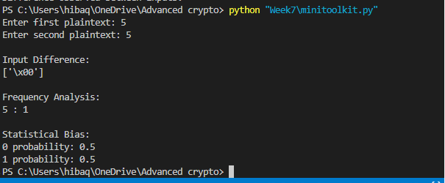
Fig2: The program compares two plaintext values and calculates their input difference. Since both inputs are the same, the difference is zero (\x00).
Frequency analysis counts the occurrence of the entered character, while statistical bias shows an equal distribution of 0s and 1s (0.5 each).

Challenge Task

Top of Form

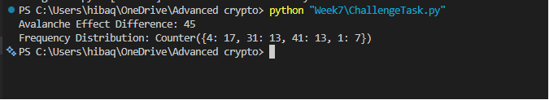Bottom of Form
Avalanche Effect: Plaintexts 6 and 7 differ by one bit, yet their ciphertexts differ significantly (35). This confirms the avalanche property: small input changes produce large output differences.
Difference Analysis: XOR differences reveal how input variations propagate through encryption.
Frequency Distribution: The analyzer shows how often each ciphertext value appears in a dataset. A secure cipher should produce outputs with balanced distribution, avoiding statistical bias.
Statistical Reporting: The results demonstrate how attackers might exploit uneven distributions, reinforcing why strong S-Boxes and multiple rounds are critical in modern ciphers like AES.

Student Reflection
This challenge task provided practical insight into how cryptanalysis evaluates cipher strength. Implementing avalanche testing and frequency analysis showed how attackers detect weaknesses, while statistical reporting highlighted the importance of non-linearity and diffusion. The experiment reinforced why AES remains secure: its design ensures balanced outputs, strong avalanche properties, and resistance to differential and linear attacks.

Week 8: Public Key Infrastructure (PKI) and Digital Certificates

Digital Certificate Security Incident Report: Entrust Certificate Authority Distrust (2024)

Introduction
Digital certificates are essential for securing online communications through the Public Key Infrastructure (PKI). Certificate Authorities (CAs) are trusted organizations responsible for issuing and managing these certificates. In 2024, a significant incident affected Entrust, a major Certificate Authority, after concerns were raised regarding certificate issuance practices and compliance failures.

1. Organization Involved
The organization involved in the incident was Entrust, a globally recognized Certificate Authority that provides SSL/TLS certificates, digital signatures, and identity management solutions. Entrust certificates are widely used by businesses and government organizations to secure websites and online services.

2. Cause of the Incident
The incident resulted from repeated certificate compliance failures and certificate mis-issuance events reported over several years. Investigations by browser vendors found that Entrust had issued certificates that did not fully comply with industry requirements established by the CA/Browser Forum.
In addition, browser vendors criticized Entrust for slow incident response, inadequate corrective actions, and failure to demonstrate consistent improvement after previous security incidents. These issues reduced confidence in Entrust's ability to operate as a publicly trusted Certificate Authority.

3. Impact on Users
The incident affected website operators and internet users worldwide. Google announced that Chrome would no longer trust newly issued Entrust certificates after November 2024.
For users, websites using affected certificates could display security warnings, making the sites appear unsafe and potentially preventing access. Organizations using Entrust certificates were required to migrate to alternative Certificate Authorities to avoid service disruptions and loss of customer trust.
The incident also increased operational costs for organizations because certificates had to be replaced and reconfigured within short timeframes.

4. Corrective Actions Taken
Several corrective measures were implemented following the incident:
- Entrust introduced stricter certificate issuance controls and review procedures.
- Additional automated certificate validation and linting tools were deployed to detect compliance issues before certificate issuance.
- Change control processes were strengthened to improve oversight of certificate management systems.
- Organizations using Entrust certificates were advised to migrate to other trusted Certificate Authorities.
- Browser vendors increased monitoring and enforcement of CA compliance requirements.
These actions were intended to restore confidence in Entrust's operations and improve overall PKI security.

5. Lessons Learned for PKI Security
The incident provides several important lessons for PKI security:
- Certificate Authorities must strictly comply with industry standards and regulations.
- Transparency and rapid incident reporting are essential for maintaining trust.
- Automated certificate validation tools should be used to reduce human errors.
- Organizations should continuously monitor certificate inventories and prepare for rapid certificate replacement if required.
- Browser vendors and CAs must work together to maintain the integrity of the global PKI ecosystem.

Practical Task : Implementing Diffie-Hellman Key Exchange

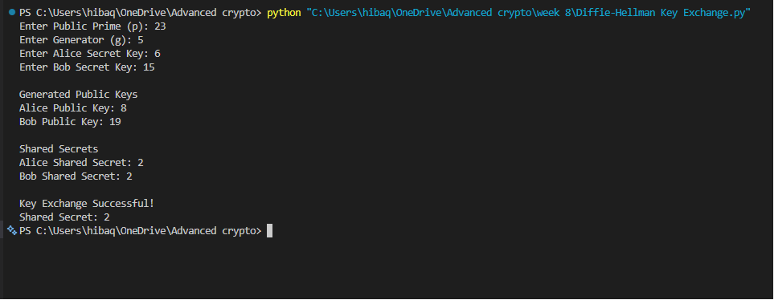

This demonstrates the core principle of the Diffie-Hellman protocol: two parties can establish the same secret key over an insecure communication channel without transmitting the secret itself.

THE ROLE OF THE DIFFIE-HELLMAN KEY EXCHANGE IN MODERN INTERNET SECURITY

Introduction
Modern internet communication relies heavily on cryptographic protocols to ensure confidentiality, integrity, and authenticity of data. One of the most important developments in public key cryptography is the Diffie-Hellman Key Exchange (DHKE), introduced in 1976 by Whitfield Diffie and Martin Hellman. The protocol revolutionized secure communications by allowing two parties to establish a shared secret key over an insecure communication channel without previously sharing any secret information. Today, Diffie-Hellman remains a fundamental component of internet security protocols, especially Transport Layer Security (TLS).

1. Definition of Diffie-Hellman
The Diffie-Hellman Key Exchange is a cryptographic protocol that enables two communicating parties to securely generate a common secret key over a public network. Unlike encryption algorithms that directly encrypt data, Diffie-Hellman is a key agreement protocol whose primary purpose is to establish a shared secret that can later be used with symmetric encryption algorithms such as AES.
The significance of Diffie-Hellman lies in its ability to solve the problem of secure key distribution. Prior to its invention, exchanging encryption keys securely required physical delivery or pre-established trust relationships. Diffie-Hellman eliminated this limitation by allowing secure key generation over untrusted networks such as the Internet.

2. How the Protocol Works
The Diffie-Hellman protocol relies on mathematical operations involving modular arithmetic.
First, both parties publicly agree on two values:
- A large prime number (p)
- A generator value (g)
These values are public and can be known by anyone.
The first participant, traditionally called Alice, selects a private secret number (a) and computes:
A = g^a mod p
The second participant, Bob, selects a private secret number (b) and computes:
B = g^b mod p
Alice sends A to Bob, while Bob sends B to Alice through the public channel.
Alice then computes the shared secret:
K = B^a mod p
Bob computes:
K = A^b mod p
Due to the mathematical properties of modular exponentiation, both computations produce the same value:
K = g^(ab) mod p
This shared value becomes the secret session key used for encryption.
An attacker can observe p, g, A, and B, but cannot practically determine the shared secret without knowing either private value a or b.

3. The Discrete Logarithm Problem
The security of Diffie-Hellman depends on the computational difficulty of the Discrete Logarithm Problem (DLP).
Given:
A = g^a mod p
it is computationally easy to calculate A if g, a, and p are known. However, determining the private value a from the public values A, g, and p is extremely difficult when sufficiently large numbers are used.
This one-way mathematical property forms the foundation of Diffie-Hellman security. Current cryptographic standards typically use prime numbers of 2048 bits or larger to make brute-force attacks computationally infeasible.
However, advances in computing power and cryptanalysis continue to challenge older implementations that use smaller key sizes.

4. Applications in TLS/SSL
Diffie-Hellman plays a critical role in TLS and SSL protocols that secure web browsing, online banking, email communication, and virtual private networks.
During a TLS handshake, the client and server use Diffie-Hellman to establish a shared session key that is subsequently used to encrypt communication using symmetric algorithms such as AES.
Modern TLS implementations primarily use two variants:
- DHE (Ephemeral Diffie-Hellman): Generates temporary session keys for each connection.
- ECDHE (Elliptic Curve Diffie-Hellman Ephemeral): Uses elliptic curve mathematics to achieve equivalent security with smaller key sizes and improved performance.
ECDHE has become the preferred method in modern TLS versions because it offers strong security with lower computational overhead.
One important advantage of DHE and ECDHE is the provision of Perfect Forward Secrecy (PFS). This means that even if a server's long-term private key is compromised in the future, previously recorded encrypted sessions cannot be decrypted because each session uses unique temporary keys.

5. Security Challenges and Possible Solutions
Although Diffie-Hellman is highly secure when properly implemented, several challenges exist.

Man-in-the-Middle Attacks
The original Diffie-Hellman protocol does not authenticate communicating parties. An attacker could intercept the key exchange and establish separate keys with both parties without their knowledge.
Solution: Use digital certificates and certificate authorities within TLS to authenticate identities during the handshake process.

Weak Parameter Selection
Using small prime numbers or weak cryptographic parameters can make attacks feasible.
Solution: Use recommended key sizes of at least 2048 bits for traditional Diffie-Hellman and secure elliptic curves for ECDHE implementations.

The Logjam Attack
The Logjam attack demonstrated that servers using weak 512-bit export-grade Diffie-Hellman parameters could be compromised by attackers with sufficient computational resources.
Solution: Disable weak cipher suites and enforce modern TLS configurations using strong parameters.

Quantum Computing Threats
Future quantum computers may be capable of solving the Discrete Logarithm Problem efficiently using algorithms such as Shor's Algorithm.
Solution: Researchers are currently developing post-quantum cryptographic algorithms that can resist quantum attacks and eventually replace current public key systems.

